Step by step instructions for deploying MTConnect Agent

Michaloski, John L. (Fed)

11/17/2016 5:13:00 PM

## Abstract

This document describes steps for deploying MTConnect Agent. These are step by step instructions, which will walk you through installing, running as application, dealing with problems (such as firewall) and then instsalling and using 24/7 as a service. There is no guarantee for success. Patience and google search are your best friends. Some items (such as firewall) are covered, but it is expected that the user will do a little research to understand how to change the firewall for a particular OS.

# Steps for Forwarding Agent

1. Check machine architecture. Make sure it is 64 bit.
   1. Is this a Win 7 64  bit machine?  Exe can be picky about  32 or 64 bit exe.
   2. 32 bit MTConnect 1.2/1.3 agents will not run on 64 bit platforms.
   3. Windows 10 has its own issues.
2. Install agent. Make sure agent installed ok
   1. Could already have agent installed with same GUID. Remove old one.
   2. check Config.ini for

[MTCONNECT]

fwdport=5010

backurl=agent.mtconnect.org:80

refresh=5

servicename=MTConnectAgentFwd

* 1. Make sure the MTConnect agent you are forwarding is specified correctly
     1. backendurl= 168.129.10.20:5000
  2. Make sure web service for this machine are what you want
     1. servicename=MTConnectFwdAgent
     2. fwdport =5000
  3. Change file permissions in mtconnect installation folder so Everyone has read/write permission

Test to see if this is the case: Edit and save Config.ini to see if the file permissions are correct in the install folder. If not, you need to run superuser.bat in the instation folder as administrator.

* + 1. cd c:\Program Files\MTConnectXXX\ (installation folder)
    2. right click superuser.bat and click "Run As Administrator". Enter user name and password. You must have administrator rights to do this. Afterwards, all the files in the folder will have read/write permissions for "Everyone."

2) Check application works. Change directory to C:\Program Files\MTConnect\ AgentForwardingSetupX64

1. Run.bat - Right click run as administrator
2. Console window pops up, will be blank until a web server trys to get /current data.
3. try web browser 127.0.0.1:port#/current For example: 127.0.0.1:5010/current in Google chrome.   See anything? In th console you should see:

127.0.0.1 - - [21/Nov/2016 12:00:20] "GET /current HTTP/1.1" 200 -

127.0.0.1 - - [21/Nov/2016 12:00:20] "GET /styles/Streams.xsl HTTP/1.1" 200 -

127.0.0.1 - - [21/Nov/2016 12:00:20] "GET /favicon.ico HTTP/1.1" 200 -

127.0.0.1 - - [21/Nov/2016 12:00:39] "GET /favicon.ico HTTP/1.1" 200 -

In the web browser, you may not see anything, but you will see above in console. Right click in Web browser and click View Page Source, and then hopefully a new window tab will pop up with the MTConnect XML.

1. Instead, you can use VBScript  MTConnectPage-1.4.vbs in the install folder, to determine if tag names working, e.g., mode->controllermode You will see a cleaner output. Enter into the input box:

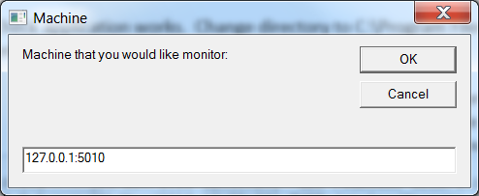

You should see (if using agent.mtconnect.org:80) this table in an Internet Explorer web page:

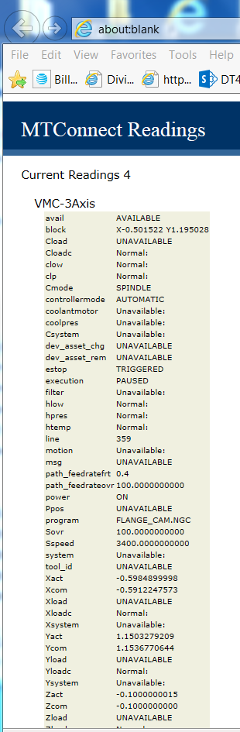

1. Problems: firewall blocking local 127.0.0.1 socket port, or remote connection.

3) Try running service

1. Open the service control manager
2. Start the agent (whatever you named it or the default) - actually start and stay alive?
3. then see web browser 127.0.0.1:port#/current    See anything? Repeat instruction from step 2 in verifying agent is working.

4) If this fails, have to change debug level and see what's up in debug.txt (where is it failing?)

5) Test remote access. Go onto a remote machine at access the agent via a web page and the MTConnect agent PC ip addres:5000/current (or whatever the service port is).

6) Test service and leaking. Make sure the MTConnect agent service restart ok, and does not start 2 instances of agent (you will need to verify this in the Task manager – look for the MTConnect exe name in the process list – make sure you click the "Show Process From All Users" button in the task manager, as the service is a SYSTEM account, not the local user account.

# Changing FIREWALL to allow MTConnect Agent through

This is how the firewall is presented after you request "Advanced Features" in Windows Filewall under the Control Panel:

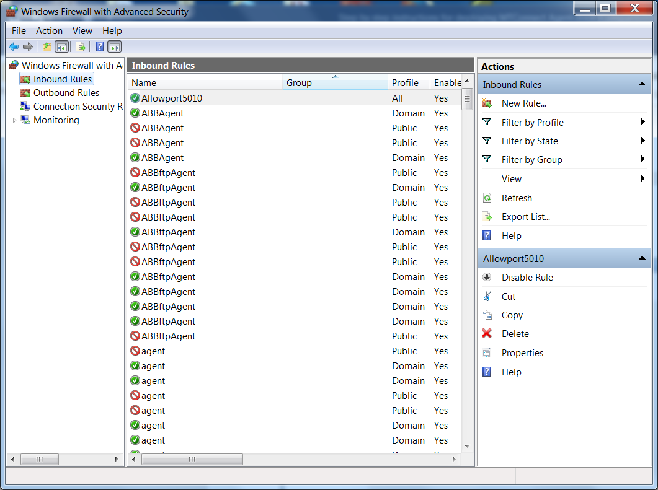

Request a "New Rule" from the "Inbound Rules" panel on the right side of the window.

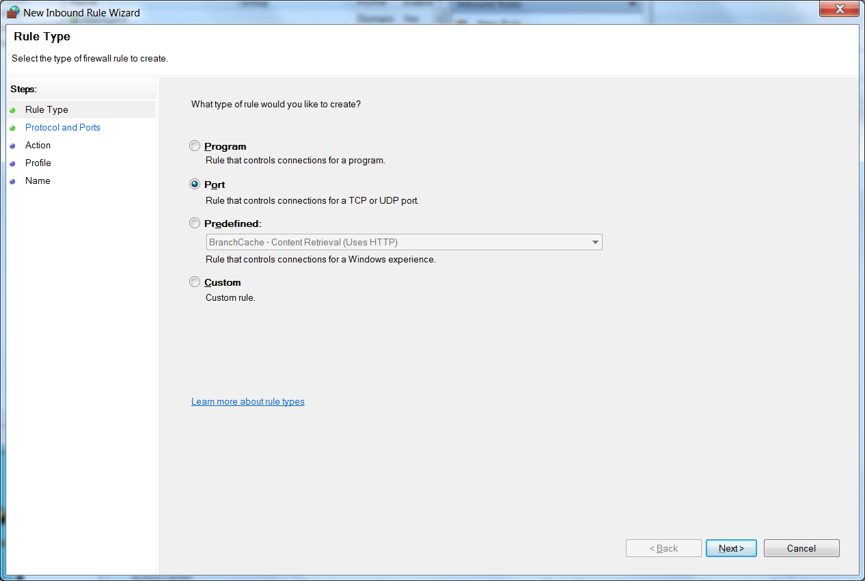

Designate the xxx port number that matches ipaddress:xxxx/current (in the case shown below 5010)

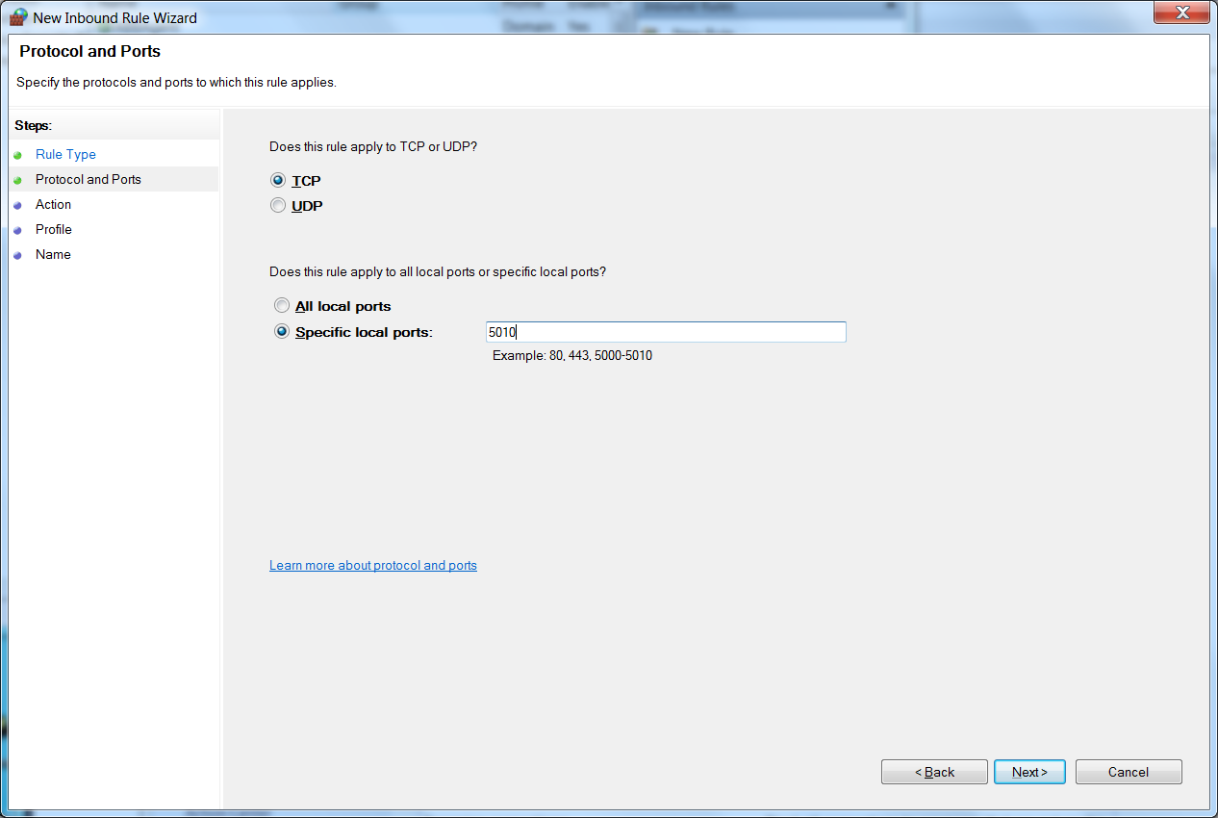

Allow !

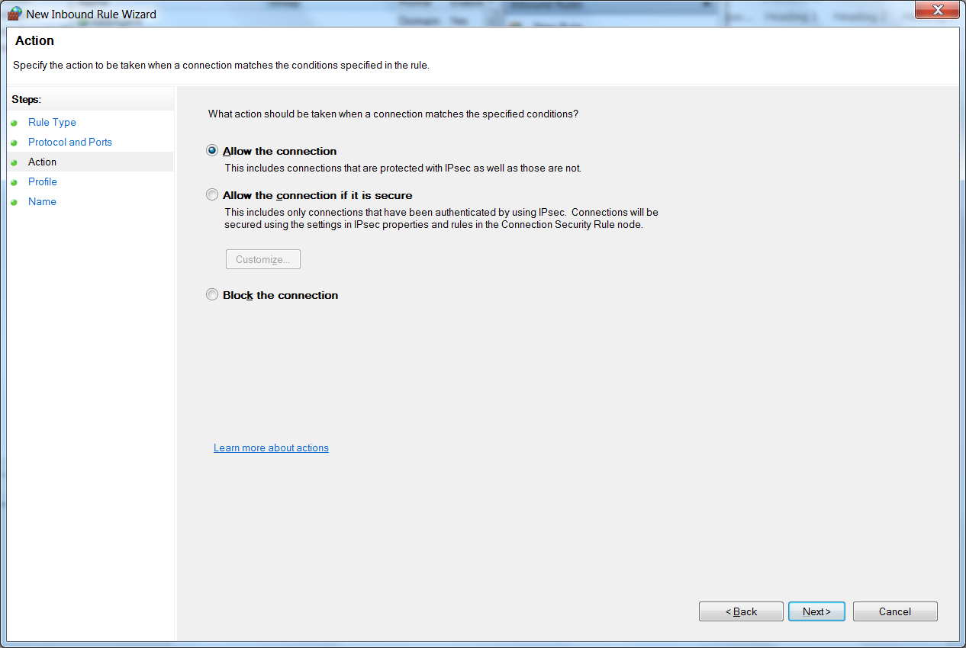

All is best..

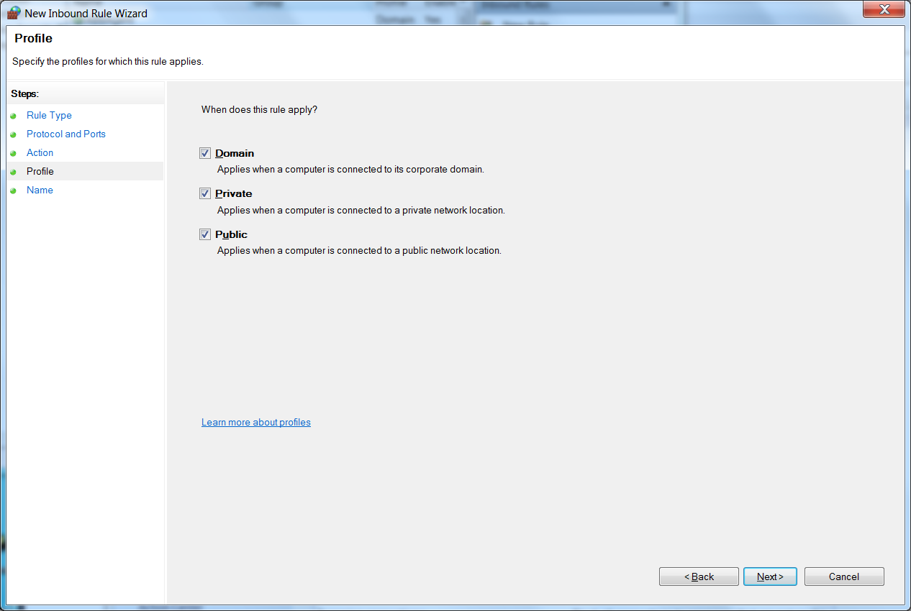

Give name and optional description:

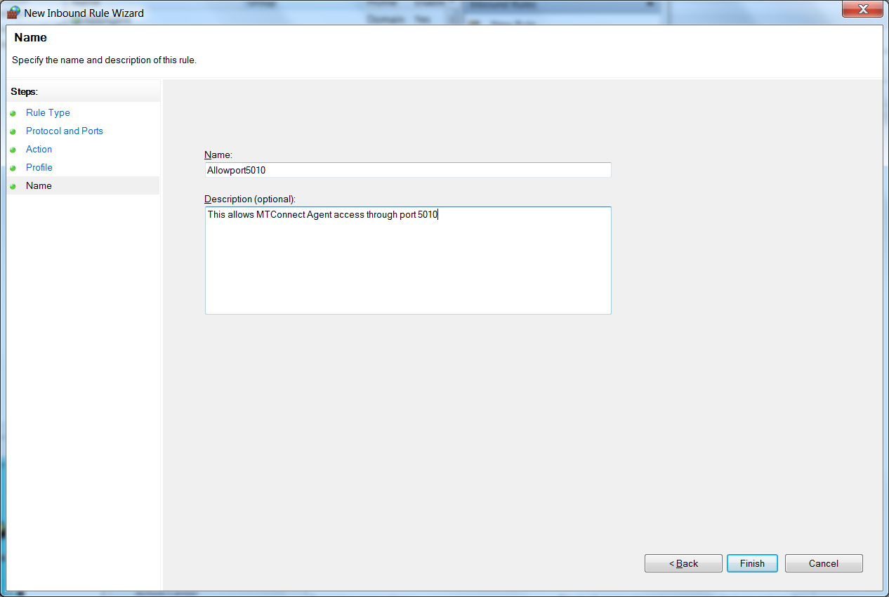

Double check opening inbound port came through:

